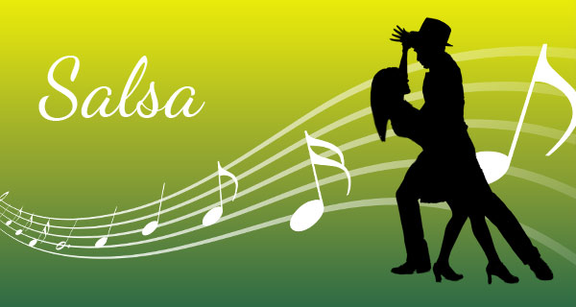

We dance Salsa and Bachata every two weeks on Friday from 12:45 to 13.30 in the Artist Studio run by Franco Betta.

The goal is to meet people and spend a good time dancing these two Latino American dances.

For all those interested it is not necessary to come in a couple.

We start dancing “pasitos de salsa” individually and then we give some technical advice to those who dance for the first time.

Lessons are free of charge.

