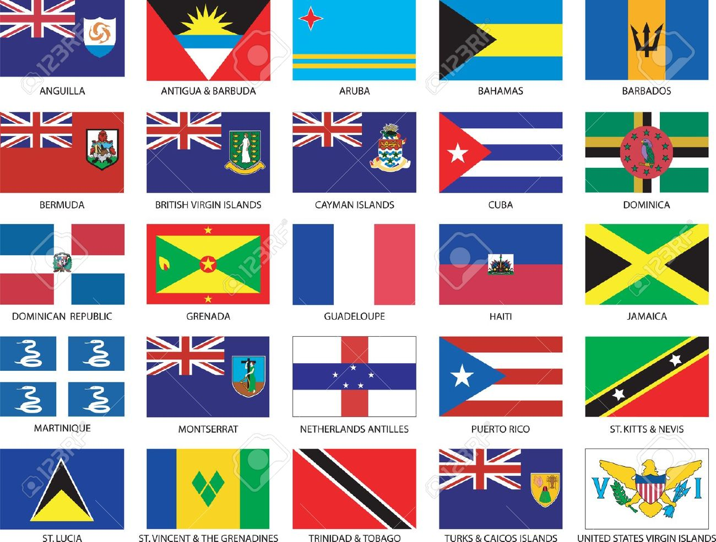

Caribbean cultural

Coordinator: Susan Murray Extn. 56875
Under the umbrella of the FAO Staff Coop the Caribbean Cultural Group has the following objectives:
1. To promote Caribbean culture and cohesion (e.g. literature, gastronomy, music and dance), by organizing, hosting and supporting cultural shows, fêtes, seminars, information exchange and social events (e.g. anniversaries, notable Caribbean dates, festivals, etc.) of interest to the membership, FAO, WFP and the larger community of Rome).

2. To raise funds periodically through cultural events, dinners/lunches, parties, raffles, charity sales, etc. to support needy, worthy and self-help organizations and causes in the Caribbean.
3. To welcome and assist new staff, visitors and others arriving from the Caribbean to FAO and other Rome-based agencies, in getting "acclimatized" and/or established in Rome, thus serving as a contact/information point.
4. To promote Caribbean goodwill and Caribbean countries as a tourist destination.

Examples of Activities:
- Fund-raising-Carnival activities
- Fund raising Charity Sales
- Art Exhibition of Caribbean works
- Celebration of CARICOM Day
- Participation in World Food Day fund raising activities

